В1

Issue Title: Button "Need help?" prevents you from seeing the interface completely

Issue Type: Bug

Priority: Р2

Author: Oleksandra Herasymova

Severity: Мedium

Description

The main page is launched and open

Steps:

1. Open the page https://oxford-med.com.ua/ua/

Expected result: See the entire site interface

Actual result: Button "Need help?" prevents you from seeing the entire site interface

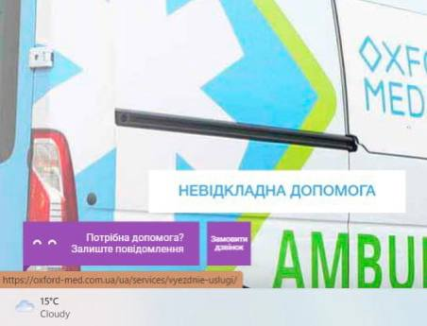

В2

Issue Title: When you go to video reviews, half of the site is empty

Issue Type: Bug

Priority: Р3

Author: Oleksandra Herasymova

Severity: Мedium

Description

The main page is launched and open

Steps:

1. Open the page <https://oxford-med.com.ua/ua/>
2. Scroll to the middle of the page
3. Click on video reviews

Expected result: The page interface is completely filled

Actual result:Video reviews are only on half the page, the other half is blank

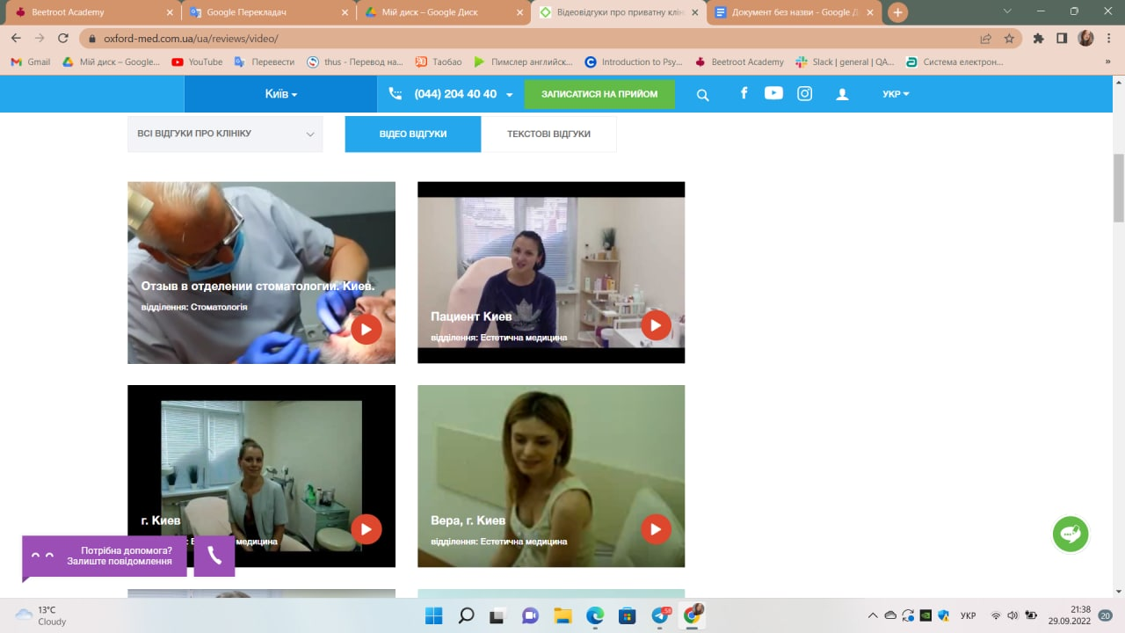

В3

Issue Title: The text at the end of the page is not aligned evenly

Issue Type: Bug

Priority: Р3

Author: Oleksandra Herasymova

Severity: Low

Description

The main page is launched and open

Steps:

1. Open the page <https://oxford-med.com.ua/ua/>
2. Scroll to the end of the page

Expected result: Correct columns of text

Actual result: Columns of text have gone astray

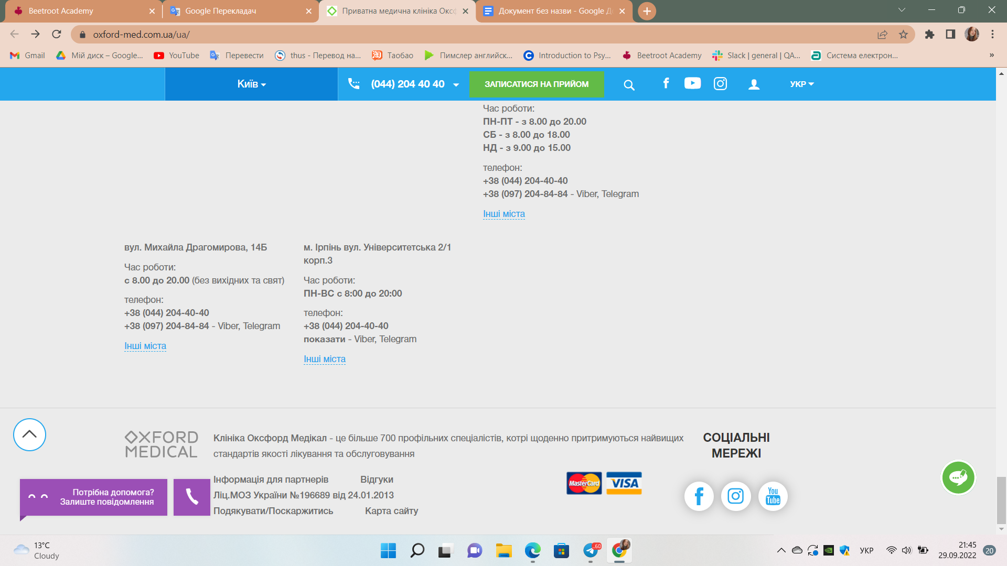

В4

Issue Title: The number of stars from one account is infinite

Issue Type: Bug

Priority: Р1

Author: Oleksandra Herasymova

Severity: Low

Description

The main page is launched and open

The clinic's reputation is being undermined due to suspicion of vote rigging

Steps:

1. Open the page <https://oxford-med.com.ua/ua/>
2. Go to the general surgery tab
3. Scroll down
4. Press the star in the rating

Expected result:Each time you click on the star, you will be asked to enter the office

Actual result: Clicking on the stars is endless

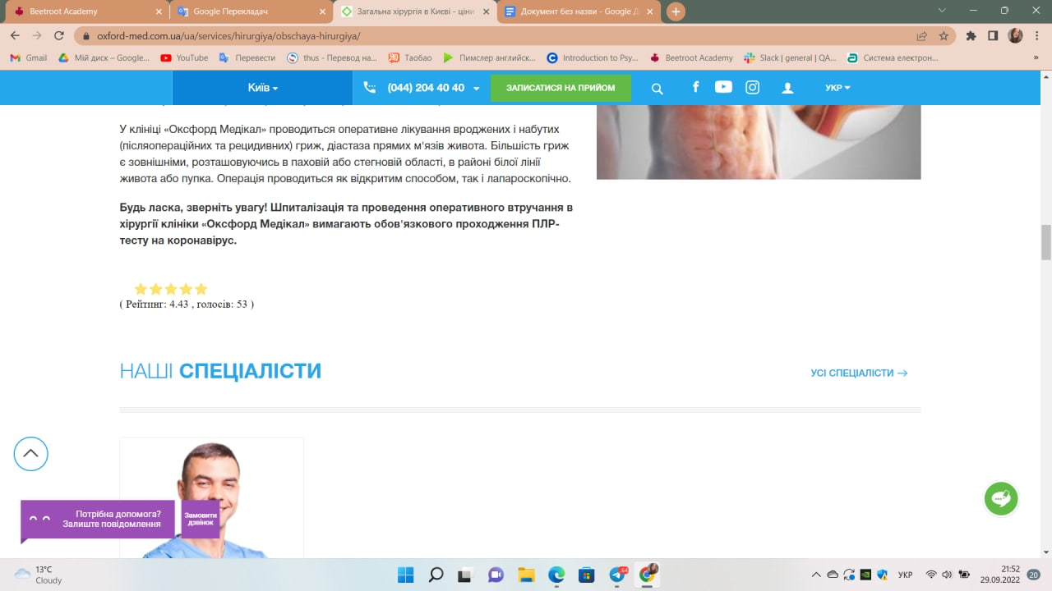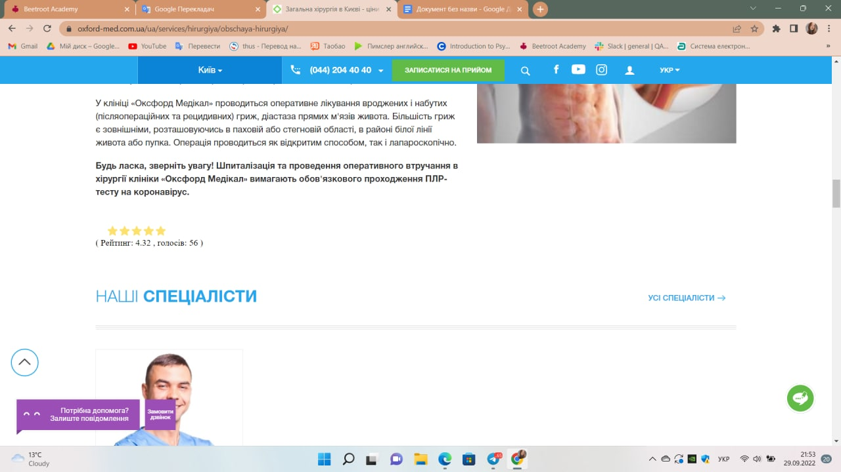

В5

Issue Title: Clicking on "Doctor's appointment" opens the article

Issue Type: Bug

Priority: Р3

Author: Oleksandra Herasymova

Severity:Medium

Description

The main page is launched and open

Steps:

1. Open the page <https://oxford-med.com.ua/ua/>
2. Go to attachment Surgical hospital
3. Go to the Tick Removal attachment
4. Click on the ad on the left

Expected result:A form for filling in a doctor's appointment, free hours, etc. opens.

Actual result: The same article is torn off

